|  |  |  |  |  |
| --- | --- | --- | --- | --- |
| **[RX-7 Home](http://autosportracetech.com/RX-7/rx7stuff.htm)** | [**Overview**](http://autosportracetech.com/RX-7/TurbochargerOverview.htm) | [**Troubleshooting**](http://autosportracetech.com/RX-7/TurboTroubleshooting.htm) | [**Symptoms**](http://autosportracetech.com/RX-7/symptoms.htm) | [**FAQs**](http://autosportracetech.com/RX-7/faqs.htm) |

**Turbocharger Overview:**

Overview of exhaust and intake air flow through turbocharger. Click image for higher resolution (~90K).

[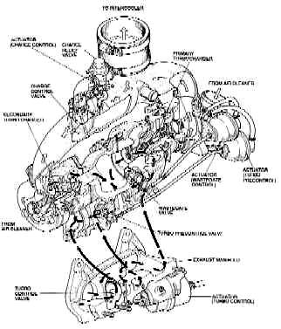](http://autosportracetech.com/RX-7/TurbochargerBigPicture.htm)

**Turbocharger Control System**

|  |  |  |  |
| --- | --- | --- | --- |
| RPM | 0 to 3,000 | 3,000 to 4,500 | 4,500 to redline |
|  | Light Load ------------------------------------------------------------------------------>> Heavy Load | | |
| Primary Turbo | Boost | | |
| Secondary Turbo | Stop | Preliminary Rotation | Boost |
| Turbo Pre-Control | Duty Control | | Duty 5% (fully open) |
| Wastegate Control | Duty 95% (fully closed) | | Duty Control |
| Charge Releif | OFF (vent to air cleaner) | | ON |
| Charge Control | ON (isolate Primary and Secondary Compressors) | | OFF |
| Turbo Control | OFF | | ON |

**0 to 3,000 RPM**

* In this RPM range, boost is produced by the Primary Turbocharger only. At this time, most of the the exhaust is directed to the Primary Turbo by the Turbo Control, and the Secondary Compressor is isolated from the Primary by the Charge Control. Boost pressure is mostly regulated by the Turbo Pre-Control.

**3,000 to 4,500 RPM**

* In this RPM range the Turbo Pre-Control valve is almost fully opened and preliminary rotation of the Secondary Turbo has begun, any boost pressure from the Secondary Turbo is vented via the Charge Releif Valve to the air cleaner. Boost pressure is regulated by the Turbo Pre-Control and the Wastegate Control.

**At 4,500 RPM**

* At this time, the Secondary Turbo is at full preliminary rotation speed, the Turbo Control is opening, Charge Releif closes causing the Secondary Turbo to surge for a short time. The Charge Control then allows Secondary boost to be added to the Primary boost.

**4,500 to Redline**

* The Turbo Control is fully opened, and boost pressure is created by the Primary and Secondary Turbochargers. When both Turbochargers are actuated, boost prerssure regulation is preformed by the Wastegate Control.

From the above description, there is not much happening when only the Primary Turbocharger is operating. However, at 4,500 RPM when the change over occurs, lots of solenoids and actuators are changing operation. This is when most of the problems occur.

Visits http://www.mecca.ca/cgi-bin/count.cgi?dvanditmars

**Troubleshooting Sequential Turbocharger problems:**

**Primary Turbocharger**

You first need to get the Primary Turbocharger working before attempting to fix anything on the Secondary Turbocharger. The Secondary Turbocharger requires the Primary Turbocharger to generate more than 8 psi of boost to properly operate actuators that control the Secondary Turbocharger.

It is also recommended to perform a [Boost Road Test](http://autosportracetech.com/RX-7/BoostTest.htm#NormalBoostPattern) to get your boost pattern before getting into all those hoses.

When you first start looking around the engine bay you may notice more than a few vacuum hoses, well most of them are under the intake manifold, check out the [colored vacuum hose diagram](http://autosportracetech.com/RX-7/vacuum.jpg). Do not be too alarmed about this, as the trouble shooting typically narrows down to a couple of actuators and or hoses.

**Primary Turbocharger Leaks**

In order for the Primary Turbocharger to operate and generate more than 8 psi of boost check the items indicated on the [Primary Turbocharger Leak Diagram](http://autosportracetech.com/RX-7/PrimaryTurboLeakDiagram.htm). The items below are on the diagram and are listed in most likely to fail order:

Y-Pipe connector hose, (coupling)

* This is a very common failure part. This short hose, (coupling) will split and vent boosted air in copious amounts. The trick with this one is that when just looking at the part on the car it will look just fine. You need to remove the 90 degree plastic duct on top and completely remove the rubber coupling, then examine the rubber coupling by gently stretching it to see if there are any splits. The splits commonly occur where the bottom hose clamp digs into the rubber. Typically costs about $47 at dealer.
* A more permanent fix that also increases the Turbocharger's efficiency is to get a '99 J-Spec [Efini] Y-pipe replacement. Most of the aftermarket vendors can get this for you. This has better air flow characteristics and replaces the rubber coupling and plastic pipe with an all metal design.

Check ~1" diameter hoses for leakage

* If you can rotate these hoses while attached, then the clamps are too loose. Get properly sized screw-clamps if the stock ones are not up to the job. New hoses will also help, but usually tightening the hose clamps is enough. These hoses can have splits also, causing leakage of boost pressure, so check for this while you have them off. A sign that there is air leakage is the presence of oily dirt on the aluminum casting around the hoses. New hose-clamps will set you back about $10 maximum for good ones. Note, clean up the oily dirt around the aluminum so that you will be able to see if these hoses start to leak again.

Primary Turbo Inlet

* Typically collapses under high volume air through air cleaner into Primary Turbocharger. When the engine bay is hot the rubber is more prone to collapsing. Typical symptoms are having good boost at lower RPMs and then a loss of boost at higher RPMs, this is aggravated when engine warms-up softening the rubber allowing for easier and more complete collapse of the hose. Typically costs about $90 at dealer.

To/From Intercooler

* Same symptoms as the Y-Pipe coupler. This includes the plastic cross-over pipe between the Y-Pipe and the intercooler, which can develop cracks that open up under boost pressure. When under boost, the hose-clamps prevent the hose from expanding due to the air pressure inside the hose. Do not under-estimate the force of 10 psi or more on 3" diameter hoses, what looks OK with engine not running may not work under boost conditions.

Air Bypass Valve

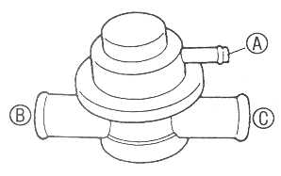Test for leakage and operation. With nothing connected to port (A), verify that port (B) can hold 15 psi of pressure and/or that port (C) can hold 30 inHg. With a vacuum tester apply 3.9-6.7 inHg of vacuum to port (A), verify air will flow from port (B) to port (C). At 9.2 inHg of vacuum to port (A) the valve will be fully open. The Air Bypass Valve is essentially the factory blow-off valve. It is not computer controlled, but simply operates by the vacuum from the Intake Extension Manifold, (pressure = closed, vacuum = open). You will hear the Air Bypass Valve vent boost when you let off the gas and get a vacuum in the Intake Extension Manifold. Typically costs about $125 at dealer. Note that the operating points of the Air Bypass Valve are different from the [Charge Relief Valve](http://autosportracetech.com/RX-7/TurboTroubleshooting.htm#ChargeReliefValve), but can be interchanged temporarily for testing.

Charge Control Solenoid / Actuator / Valve

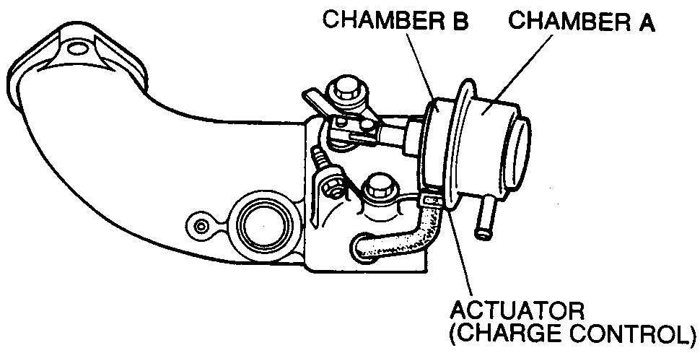The Charge Control Valve controls the transition from Primary to combined Primary and Secondary Turbocharger operation. When ever the pressure applied to both Chambers of the Charge Control Actuator are equal, the spring force of the Charge Control Actuator will open the Charge Control Valve.

Below 4500 RPM this actuator is ON, (actuator rod pulled in), this closes the valve between the Primary and Secondary Turbochargers. This valve seals the air passage the same way as a throttle butterfly valve.

A simple test for the Charge Control Actuator is to start the engine and let it idle, the actuator rod will be pulled in. Stop the engine and remove the hose from Chamber A and the actuator rod will be out.

Chamber B is always connected to the Primary Turbo Compressor and normally will have 0 to 12 psi of boost pressure applied. Chamber A is connected to the Charge Control Solenoid, from 0 to 4,500 RPM a vacuum, from the [Vacuum Chamber](http://autosportracetech.com/RX-7/TurboTroubleshooting.htm#VacuumChamber) is applied, above 4.500 RPM the Secondary Turbo Compressor is applied to chamber A.

From 0 to 4,500 RPM with a vacuum applied to Chamber A, the Charge Control Valve stays closed, as Primary boost is always greater than a vacuum. Note, that the vacuum supply is from the [Vacuum Chamber](http://autosportracetech.com/RX-7/TurboTroubleshooting.htm#VacuumChamber), thus leakage of the one-way check valve for the [Vacuum Chamber](http://autosportracetech.com/RX-7/TurboTroubleshooting.htm#VacuumChamber) will result in Primary boost applied on both sides of the actuator resulting in this valve opening when it should not, dumping Primary boost through the Charge Relief , Secondary Turbo and out the Charge Relief Valve. Another symptom of a leaky [Vacuum Chamber](http://autosportracetech.com/RX-7/TurboTroubleshooting.htm#VacuumChamber) one-way check valve is a loss of boost that is restored if the throttle is let off, (re-charging the [Vacuum Chamber](http://autosportracetech.com/RX-7/TurboTroubleshooting.htm#VacuumChamber) from engine vacuum) then quickly re-applying throttle results in boost.

**Primary Turbocharger Control,** (see [Turbocharger Overview](http://autosportracetech.com/RX-7/TurbochargerOverview.htm) for more details).

Turbo Pre-Control Solenoid / Actuator

* This Actuator will direct some of the exhaust from the Primary Turbo to the Secondary Turbo. This re-directing of exhaust with the Turbo Pre-Control is also used as a method to Actively regulate Primary Turbo boost pressure, (instead of using the Wastegate). The Turbo Pre-Control is controlled by the ECU [duty-controlling](http://autosportracetech.com/RX-7/faqs.htm#DutyCycleControl) the Solenoid. The ECU controls the Turbo Pre-Control solenoid in a fixed manner based on RPM and boost pressure.
* Another problem is that the Turbo Pre-Control door is slightly ajar robbing exhaust for the Primary Turbo. The solution is in properly setting the length of Turbo Pre-Control Actuator rod. Disconnect the rod from the the door by removing the C-clip, hold the door closed and set the length of the rod so that one half of the arm pin is hidden by the hole in the rod end. Then reattach the rod, you will have to pull on the rod in order to get the hole to go over the pin of the arm. Remember to put that 5-7mm E-clip back on.
* The hose from the Primary Turbo Compressor to the Turbo Pre-Control Actuator, (the one with the pill in it) can get old and can expand it's inner diameter around where the pill is, effectively creating a larger opening than the pill size for air to go through, causing lower Primary boost and sluggish transition for the Secondary Turbo.
* If boost pressure is way above 10 psi, (i.e. spiking at >14 psi) then the tube between the Primary Turbo Compressor and the Turbo Pre-Control Actuator has popped off. Do NOT simply plug the popped off hose back on as it will pop off again. always use a new small hose clamp or a nylon zip-tie / ty-wrap for these hoses.

Wastegate Solenoid / Actuator

* With only the Primary Turbocharger in operation, the Wastegate is NOT actively controlled by the ECU. Once boost pressure reaches about 10 psi, the Wastegate starts to open to bypass some of the exhaust around the Turbocharger, thus slowing down the Turbocharger. The Wastegate is not actively controlled by the ECU when below 4,500 RPM. The Wastegate solenoid is put in a fixed high [duty cycle](http://autosportracetech.com/RX-7/faqs.htm#DutyCycleControl), (95% of the time on) which results in most of the air being vented from the Wastegate Actuator. At about 8 psi the Wastegate Actuator starts to move and by 10 psi the Actuator has moved enough to regulate the boost pressure to 10 psi. If boost is at 6 - 7 psi the [pill](http://autosportracetech.com/RX-7/faqs.htm#Pills) to the wastegate could be missing, the Wastegate solenoid is not operating at 95% [duty cycle](http://autosportracetech.com/RX-7/faqs.htm#DutyCycleControl), or the Wastegate is not mechanically connected to the actuator.
* Another problem is that the Wastegate door is slightly ajar robbing exhaust for the Primary Turbo. The solution is in properly setting the length of Wastegate Actuator rod. Disconnect the rod from the the door by removing the C-clip, hold the door closed and set the length of the rod so that one half of the arm pin is hidden by the hole in the rod end. Then reattach the rod, you will have to pull on the rod in order to get the hole to go over the pin of the arm. Remember to put that 5-7mm E-clip back on.
* The size of the [pill](http://autosportracetech.com/RX-7/faqs.htm#Pills) to the Wastegate Actuator in conjunction with the fixed 95% [duty cycle](http://autosportracetech.com/RX-7/faqs.htm#DutyCycleControl) of the solenoid controls the maximum Primary Turbo boost pressure.
* The hose from the Primary Turbo Compressor to the Wastegate Actuator, (the one with the pill in it) can get old and can expand it's inner diameter around where the pill is, effectively creating a larger opening than the pill size for air to go through, causing lower Primary and Secondary boost.
* If boost pressure is way above 10 psi, (i.e. spiking at >14 psi) then the tube between the Primary Turbo Compressor and the Wastegate Actuator has popped off. Do NOT simply plug the popped off hose back on as it will pop off again. always use a new small hose clamp or a nylon zip-tie / ty-wrap for these hoses.

**Turbocharger Exhaust**

Exhaust Leaks

* Exhaust leaks between the Engine and the Turbocharger, (i.e. exhaust gasket), then the Turbocharger will not be able to spin up as quick and/or not maintain boost pressure.

Exhaust Restriction

* Exhaust restriction after the Turbocharger will show up as boost pressure drop-off at higher RPMs, (i.e. roll off after 6,000 RPM) the most common failure part here is the pre-cat, (sits between the turbos and the main catalytic converter). Due to the high exhaust temperatures, the pre-cats can start to fail in a plugged manner after about 50,000 miles. The common fix here is to replace the pre-cat with a down-pipe or have the pre-cat gutted. Note, check your area for emission laws with respect to the pre-cat before doing anything.

**Other Things**

Double Throttle Control

* This keeps a second set of Secondary throttle plates in the throttle body closed. If the Double Throttle control is not working properly, (i.e. secondary always closed) then maximum boost will be restricted to ~5 psi.

**Secondary Turbocharger**

You first need to get the [Primary Turbocharger](http://autosportracetech.com/RX-7/TurboTroubleshooting.htm#PrimaryExplanation) working before attempting to fix anything on the Secondary Turbocharger. The Secondary Turbocharger requires the [Primary Turbocharger](http://autosportracetech.com/RX-7/TurboTroubleshooting.htm#PrimaryExplanation) to generate more than 8 psi, (preferably 10 psi) to operate actuators that control the Secondary Turbocharger.

If you are at this point in your troubleshooting then a HIGHLY recommended tool to get is a hand-pump that can provide a vacuum as well as pressure, check out [http:\\www.mityvac.com](http://www.mityvac.com). Just about any local auto-parts/tools place will have these, also don't forget to get some "T" pipe fittings and some vacuum hose to allow tapping into various hoses. Basically you can attach this to the various actuators and solenoids to see if the they operate properly, much nicer than having to run the car to test things out.

**Secondary Turbocharger Leaks**

Assuming you have checked and verified the Primary Turbocharger for leaks there are several leakage paths specific to when the Primary and Secondary Turbochargers are operating, see the [Secondary Turbocharger Leak Diagram](http://autosportracetech.com/RX-7/SecondaryTurboLeakandControlDiagram.htm). The item(s) below are on the diagram and are listed in most likely to fail order:

Charge Relief Solenoid / Valve

Test for leakage and operation. With nothing connected to port (A), verify that port (B) can hold 15 psi of pressure and/or that port (C) can hold 30 inHg. With a vacuum tester apply 6.5-9.3 inHg of vacuum to port (A), verify air will flow from port (B) to port (C). The Charge Relief Valve vents boost during the pre-spin stage of the Secondary Turbocharger, (3,000 to 4,500 RPM). The Charge Control Valve isolates the Primary Turbocharger boost from the Secondary Turbocharger during the pre-spin stage. After 4,500 RPM the Charge Relief Valve is closed to allow Secondary boost to be added to Primary boost. Note that the operating points of the Charge Relief Valve are different from the [Air Bypass Valve](http://autosportracetech.com/RX-7/TurboTroubleshooting.htm#AirBypassValve), but can be interchanged temporarily for testing.

**Secondary Turbocharger Control,** (see [Turbocharger Overview](http://autosportracetech.com/RX-7/TurbochargerOverview.htm) for more details).

***At this time you should have the Primary Turbocharger functions completely, and checked for Secondary Turbocharger boost leaks.***

Turbo Pre-Control Solenoid / Actuator

* To prevent a drop in boost pressure when the Secondary Turbo begins to operate, the Secondary Turbo is made to spin prior to providing boost. The Turbo Pre-Control is controlled by the ECU [duty-controlling](http://autosportracetech.com/RX-7/faqs.htm#DutyCycleControl) the pre-control solenoid. The ECU controls the pre-control solenoid in a fixed manner based on RPM and boost pressure, (i.e. boost pressure regulation).

Turbo Control Solenoid(s) / Actuator

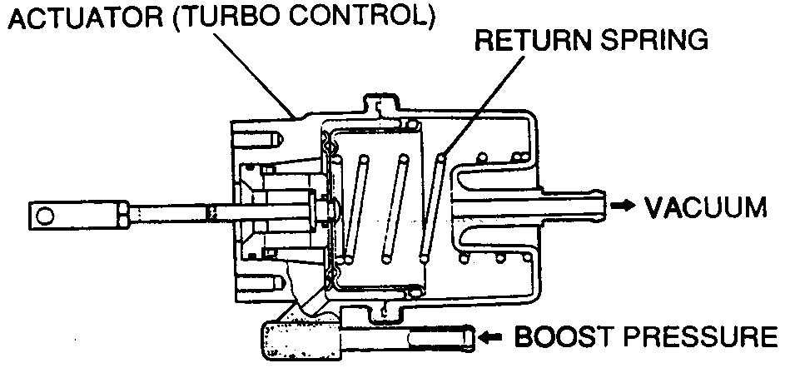The Turbo Control Solenoid / Actuator is one of the more complicated actuators as it requires both vacuum and pressure to operate properly. This actuator is controlled by two solenoids, (both are wired together to the one ECU output) one solenoid applies pressure to one side of the actuator and the other applies vacuum to the other side of the actuator. With pressure on one side and a vacuum on the other side of the actuator, the speed of the actuator is improved. A typical problem is loss of Secondary boost in 1st or 2nd gear at 4,500 RPM, but reliable operation in other gears. This points to one side of the Turbo Control Actuator not getting it's pressure/vacuum, so it will still operate but not quickly enough.

* No vacuum to the Turbo Control Solenoid / Actuator is a common failure. This is typically caused by the one-way valve that supplies vacuum to the Turbo Control Solenoid / Actuator through the [Vacuum Chamber](http://autosportracetech.com/RX-7/TurboTroubleshooting.htm#VacuumChamber). The one-way valve will leak, allowing manifold pressure to leak into the vacuum while under boost.

Charge Control Solenoid / Actuator

The Charge Control Valve controls the transition from Primary to combined Primary and Secondary Turbocharger operation. When ever the pressure applied to both Chambers of the Charge Control Actuator are equal, the spring force of the Charge Control Actuator will open the Charge Control Valve.

Below 4500 RPM this actuator is ON, (actuator rod pulled in), this closes the valve between the Primary and Secondary Turbochargers. This valve seals the air passage the same way as a throttle butterfly valve.

A simple test for the Charge Control Actuator is to start the engine and let it idle, the actuator rod will be pulled in. Stop the engine and remove the hose from Chamber A and the actuator rod will be out, see also [Boost Test Step 5](http://autosportracetech.com/RX-7/BoostTest.htm#BoostTestStep5).

Chamber B is always connected to the Primary Turbo Compressor and normally will have 0 to 12 psi of boost pressure applied. Chamber A is connected to the Charge Control Solenoid, from 0 to 4,500 RPM a vacuum, from the [Vacuum Chamber](http://autosportracetech.com/RX-7/TurboTroubleshooting.htm#VacuumChamber) is applied, above 4.500 RPM the Secondary Turbo Compressor is applied to chamber A.

From above 4,500 RPM with Secondary Turbo Compressor applied to Chamber A, when the Secondary Turbo is producing the same or more Boost than the Primary Turbo, the Charge Control Actuator's spring will allow the Charge Control Valve to open, allowing the both the Primary and Secondary Turbo provide boost.

Wastegate Solenoid / Actuator

* With both Turbochargers are in operation, the Wastegate is actively controlled by the ECU to allow exhaust to be bypassed around both of the Turbochargers to allow control of boost pressure. Once boost pressure reaches a set value, (i.e. 10 psi) then the wastegate starts to open to bypass some of the exhaust around the Turbochargers, thus slowing down the Turbochargers. The Wastegate is controlled by the ECU [duty-controlling](http://autosportracetech.com/RX-7/faqs.htm#DutyCycleControl) the Solenoid.
* Another problem is that the Wastegate door is slightly ajar robbing exhaust for the Primary and Secondary Turbo. The solution is in properly setting the length of Wastegate Actuator rod. Disconnect the rod from the the door by removing the C-clip, hold the door closed and set the length of the rod so that one half of the arm pin is hidden by the hole in the rod end. Then reattach the rod, you will have to pull on the rod in order to get the hole to go over the pin of the arm. Remember to put that 5-7mm E-clip back on.
* The hose from the Primary Turbo Compressor to the Wastegate Actuator, (the one with the pill in it) can get old and can expand it's inner diameter around where the pill is, effectively creating a larger opening than the pill size for air to go through, causing lower Primary and Secondary boost.
* If boost pressure is way above 10 psi, (i.e. spiking at >14 psi) then the tube between the Primary Turbo Compressor and the Wastegate Actuator has popped off. Do NOT simply plug the popped off hose back on as it will pop off again. always use a new small hose clamp or a nylon zip-tie / ty-wrap for these hoses.

**Other Stuff**

Wastegate and Turbo Pre-Control Solenoids

* If you are getting a solid 6 psi from 4,500 RPM up, Check the electrical connections to these two solenoids, as they can get mixed up while working on the engine. From the front of the car, the right hand solenoid and the electrical connector of the engine electrical harness have a painted white dot, these two go together. Note that over time these painted white dots tend to dissapear.
* To remove the ECU from controlling boost, simply unplug the electrical connectors for both of these solenoids, (as per above note which connector goes where). You should get about 7 psi of boost, if not then you have a boost leak, exhaust leak, or a problem with the Wastegate or Turbo Pre-Control actuators.

**One-way Check Valves, Chambers, and Tanks**

* There are several one-way check valves that are essential to proper operation of the Secondary Turbo coming on-line and staying on-line. See [Pressure Tank](http://autosportracetech.com/RX-7/TurboTroubleshooting.htm#PressureTank) and [Vacuum Chamber](http://autosportracetech.com/RX-7/TurboTroubleshooting.htm#VacuumChamber), for location details.
* Here is a list of the solenoids and related actuators and where they get their air supply from. Also an explanation of how these air supplies operate. There is a [Pressure Tank](http://autosportracetech.com/RX-7/TurboTroubleshooting.htm#PressureTank) and a [Vacuum Chamber](http://autosportracetech.com/RX-7/TurboTroubleshooting.htm#VacuumChamber), each of these are supplied air through an one-way check valve.

|  |  |
| --- | --- |
|  | [Air Supply](http://autosportracetech.com/RX-7/TurboTroubleshooting.htm#Air Supply) |
| Turbo Pre-Control Solenoid and Turbo Pre-control Actuator | [Primary](http://autosportracetech.com/RX-7/TurboTroubleshooting.htm#Primary) |
| Wastegate Solenoid and Wastegate Actuator | [Primary](http://autosportracetech.com/RX-7/TurboTroubleshooting.htm#Primary) |
| Charge Relief Solenoid and Charge Relief Valve | [Vacuum](http://autosportracetech.com/RX-7/TurboTroubleshooting.htm#Vacuum) |
| Charge Control Solenoid and Charge Control Actuator | [Vacuum](http://autosportracetech.com/RX-7/TurboTroubleshooting.htm#Vacuum) |
| Turbo Control Solenoid and Turbo Control Actuator | [Vacuum](http://autosportracetech.com/RX-7/TurboTroubleshooting.htm#Vacuum) and [Pressure](http://autosportracetech.com/RX-7/TurboTroubleshooting.htm#Pressure) |

Air Supply

* This column indicates where the solenoid and actuator gets it's air supply from.

Vacuum

* Vacuum is supplied from the [Vacuum Chamber](http://autosportracetech.com/RX-7/TurboTroubleshooting.htm#VacuumChamber), this chamber is supplied with a vacuum from the Intake via a one-way check valve. This one-way check valve allows the vacuum chamber to keep a vacuum while the intake becomes pressurized from the Turbochargers during boost.

Vacuum Chamber

* This is a black plastic tank that is buried between the alternator and power steering pump. Kind of difficult to see, removing the Pressure Chamber helps to see it, has one hose connection, and should have a hose attached, ([Engine View Picture](http://autosportracetech.com/RX-7/EngineView01.jpg)). This hose comes from the rats nest of metal tubes, and there is a one-way check valve between the rats nest of tubes and the Intake, (the only check valve located between Throttle Body and the Firewall). This one-way check valve can start to leak after a while, causing loss of vacuum to various controls when under boost for a while. A way to troubleshoot this one-way valve leaking is to note a gradual loss of boost and then drop the throttle long enough for your boost gauge to indicate at least 20 inHg of vacuum then slam the throttle back down again. If boost is back up to what it should be then replace this one-way check valve. Basically what this does is "recharge" the vacuum chamber when you let off the gas, allowing actuators to operate properly while the vacuum is still present.
* The vacuum one-way check valve goes from the Intake manifold to the Vacuum Chamber via the rats nest of tubes, (Mazda Part# N390-13-995A). This has a layer of three paper like filters on each end for separating any oil from the air.

Primary

* Primary air is supplied directly from the Primary Turbocharger compressor, no one-way check valves or pressure tanks. Note that the Primary Turbo must be operating and generating more than 7 psi of boost to be useful for any of the solenoids or actuators.

Pressure

* Pressure is supplied from the [Pressure Tank](http://autosportracetech.com/RX-7/TurboTroubleshooting.htm#PressureTank), this tank is supplied with pressure from the Primary Turbo's compressor via a one-way check valve. The one-way check valve allows the pressure tank to keep a pressure when the Primary Turbo is not producing boost and/or during the Secondary Turbo coming on-line. Note that the pressure tank requires the Primary Turbo to be operating and generating more than 7 psi of boost to be useful for any of the solenoids or actuators.

Pressure Tank

* This is a black plastic tank that is located above and between the alternator and air-pump and in front of the intake. Kind of difficult to miss, has two hose connections on the driver's side, and should have two hoses attached, ([Engine View Picture](http://autosportracetech.com/RX-7/EngineView01.jpg)). One hose comes from a one-way check valve between the Pressure Chamber and the Primary Turbo Compressor outlet, (remove the Pressure Chamber to see this one-way check valve under the Pressure Chamber). The other hose goes to various solenoids that require pressurized air. It is VERY common for either one of the hoses to the Pressure Tank or the one-way check valve to pop off due to boost pressures greater than 12 psi that the tank holds due to boost spikes and the hoses becoming old. Do NOT simply plug the popped off hose back on as it will pop off again. Replace the entire hose and always use a small hose clamp or a nylon zip-tie / ty-wrap for these hoses.
* The pressure one-way check valve goes from the Primary Turbo Compressor to the Pressure Tank, (Mazda Part# N390-13-995A ). This has a layer of three paper like filters on each end for separating any oil from the air.

**Rebuilding and/or replacing the Turbochargers**

OK, you have found out that the Turbochargers do actually need to be replaced, (major bummer). I read somewhere that anyone with a turbocharged car should really look at the turbocharger(s) as a "consumable" part, much like clutch, brakes, etc... this may make you feel better but will not help with the cash-flow situation.

If you have a Mazda dealer than knows 3rd Gen RX-7s then they can do most of the work for you. Typically the Mazda dealer removes the turbos, then sends them out for re-build at a turbo re-builder, then the Mazda dealer puts the re-built turbos back in the car. Ask them how they go about doing this and if they have done this before and used the turbo re-builder before. These are very important questions to ask and get satisfactory answers to.

If you do not know of a good Turbocharger re-builder, then look in your local Yellow Pages directory under, hey you guessed it "Turbochargers". Phone everyone listed and ask them if they have worked on your type of Turbocharger for the 3rd Gen RX-7, (they are made by Hitachi, model HT12). There are basically two types of turbocharger re-builders, one will just work on the turbo cartridge and you get to remove this from the RX-7 specific exhaust and compressor housings. The other type of re-builder will accept the whole RX-7 turbocharger assembly. Both have their advantages and disadvantages.

Turbocharger cartridge re-builders will cost you less for the re-build of the turbos, but you will need some special tools to remove the housings and some set-up jigs to have everything re-align when putting everything back together. The other thing is that typically there will be cracks in the cast iron exhaust housings, typically around the wastegate, where the exhaust enters the housing from the engine, and around the exhaust wheel of each turbo. These cracks can be anywhere from benign to irreparable depending on how deep and where they are located. Any cracks that are where the exhaust wheel is is generally considered irreparable. For around the wastegate these can be welded up or some shops can machine and put an insert in. Note that any of this type of welding must be performed at a shop that does this kind of work, see Turbocharger assembly re-builders. So in the end, you may spend about the same amount of money, except that it will not be all in the same place. Another disadvantage, is that re-assembling the turbocharger into the RX-7 housings requires lining up oil in/out fittings and compressor outlets with respect to the exhaust manifold attachment plane, non-trivial and requires measuring or adding alignment marks of the various parts prior to disassembly.

Turbocharger assembly re-builders will cost you more but you get the complete assembly under warranty. It is very important that the place you use has experience with the 3rd Gen RX-7 turbochargers, because there are a bunch of non-obvious things that a first time re-builder will not realize about re-assembly of the turbos and the housings as mentioned in the previous paragraph, (i.e. alignment of oil in/out fittings and alignment of primary and secondary compressor outputs).

Note, it is VERY common to loose the inline [pills](http://autosportracetech.com/RX-7/faqs.htm#Pills) that are between the Primary Compressor and the Wastegate and Turbo Pre-Control Actuators when having the Turbochargers replaced. Typically the re-builder will replace all hosing on the Turbocharger, and it is non-obvious that there are restrictor pills in the hoses.

[Parts and Instructions for Turbocharger Remove and Replace](http://autosportracetech.com/RX-7/TurboRe-n-Re.htm)

For questions or feedback AutoSport Race Tech Info Contact

**Symptoms:**

Note this is a work in progress.

Please drop me an email at AutoSport Race Tech Info Contactwith your symptom and fix so I can add it to here.

|  |  |  |  |  |  |  |  |  |  |
| --- | --- | --- | --- | --- | --- | --- | --- | --- | --- |
| **Primary Only** | | **4,500 RPM** | | **Primary and Secondary** | | **Check** | | | |
| Solid 7 psi | | Solid 7 psi | | Solid 7 psi | | Missing pills for Wastgate and/or Turbo Pre-Control Actuators.  Wastegate and Turbo Pre-Control Solenoids are elctrcially unplugged. | | | |
| Spikes above 14 psi | |  | | Spikes above 14 psi | | Hose from Primary Turbo Compressor to Wastegate and/or Turbo Pre-Control Actuators has popped off. | | | |
| Solid 12 psi | |  | | 5 psi or less | | One of the vacuum hoses connected to the pressure tank, pressure tank chack valve, or hose between turbo and check valve. They will come off again unless the hose is replaced or zip-tie it at both ends. | | | |
| Hear boost leak | |  | | Hear boost leak | | Y-Pipe coupler | | | |
|  | |  | |  | |  | | | |
| [**RX-7 Home**](http://autosportracetech.com/RX-7/rx7stuff.htm) | | [**Overview**](http://autosportracetech.com/RX-7/TurbochargerOverview.htm) | | [**Troubleshooting**](http://autosportracetech.com/RX-7/TurboTroubleshooting.htm) | | [**Symptoms**](http://autosportracetech.com/RX-7/symptoms.htm) | [**FAQs**](http://autosportracetech.com/RX-7/faqs.htm) |

This diagram shows the various paths the cooling system has...

Note that the turbochargers have their own separate cooling path from the engine with "A" being the return path and the hose on top being the supply path. Both of these hoses are near the exhaust manifold and turbocharger exhaust housings, thus the hoses are exposed to significant heat soak conditions. It is highly recommended that these be replaced when turbocharger(s) are re-built.

The Mazda part numbers for the two coolant hoses for the turbos are, N3A1-13-54X0, and N3A1-13-5360.

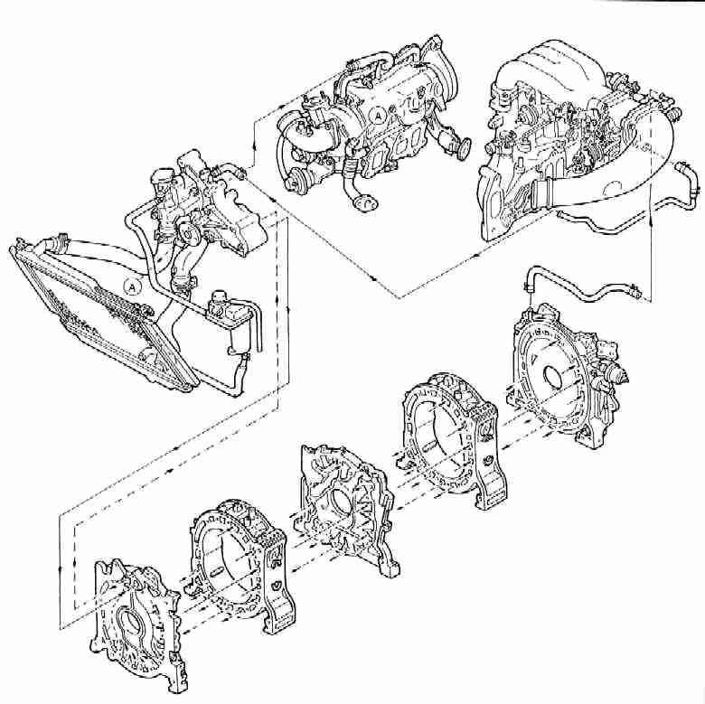

|  |  |  |  |  |
| --- | --- | --- | --- | --- |
| [**RX-7 Home**](http://autosportracetech.com/RX-7/rx7stuff.htm) | [**Overview**](http://autosportracetech.com/RX-7/TurbochargerOverview.htm) | [**Troubleshooting**](http://autosportracetech.com/RX-7/TurboTroubleshooting.htm) | [**Symptoms**](http://autosportracetech.com/RX-7/symptoms.htm) | [**FAQs**](http://autosportracetech.com/RX-7/faqs.htm) |

Oil System Diagram:

Note that "A" connection splits into two paths for each turbocharger and that there are separate oil return paths for each turbocharger. The return paths, "B" and "C" drain into the oil pan area.

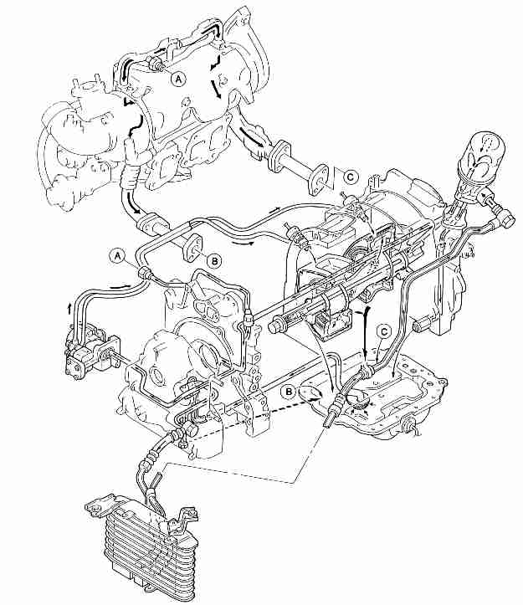

|  |  |  |  |  |
| --- | --- | --- | --- | --- |
| [**RX-7 Home**](http://autosportracetech.com/RX-7/rx7stuff.htm) | [**Overview**](http://autosportracetech.com/RX-7/TurbochargerOverview.htm) | [**Troubleshooting**](http://autosportracetech.com/RX-7/TurboTroubleshooting.htm) | [**Symptoms**](http://autosportracetech.com/RX-7/symptoms.htm) | [**FAQs**](http://autosportracetech.com/RX-7/faqs.htm) |

**Zone Correction**

* To maintain the most desirable air/fuel ratio thoughout the entire driving range, the driving range is divided into several zones based on engine speed, intake manifold pressure, and throttle position. Appropriate corrections are made in each zone.

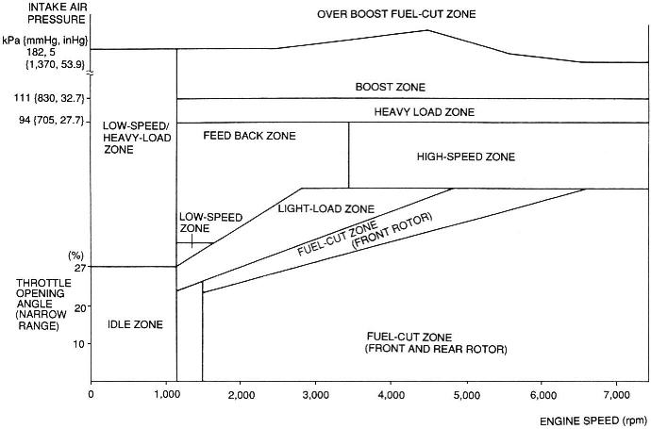

|  |  |  |  |
| --- | --- | --- | --- |
| **Fuel** | **Zone** | **Operation** | **Remark** |
| Decrease | Fuel-cut (F&R rotor) | Fuel supply is stopped during full-closed throttle deceleration | Improves drive feel and fuel efficency |
| Decrease | Fuel-cut (Front rotor) | Fuel to front rotor is cut during half-throttle deceleration | Prevents bucking |
| Increase | Light-load | Fuel amount increased | Ensures engine smoothness |
| Increase | Low-speed | Fuel amount increased | Ensures engine smoothness |
| Increase | Low-speed with Heavy-load | Fuel amount increased | Ensures engine smoothness |
| Increase | High-speed | Fuel amount increased | Ensures engine smoothness |
| Increase | Heavy-load | Fuel amount increased | Ensures engine smoothness |
| Increase | Boost | Fuel amount increased | Ensures engine smoothness |
| Increase | Idle | Fuel amount increased coresponing to the applied load | Ensures engine smoothness |
| Feedback | Feedback | During constant-speed driving, feedback control is performed based on O2 sensor | Improves exhaust gas cleansing |